Case Study: 4
Title: Development of password strength checker using HTML,CSS.
Software/Tools Required: VSC, HTML, CSS, JavaScript
Case Study program code:
<!DOCTYPE html>
<html lang="en">
<head>
<meta charset="UTF-8">
<title>Password Checker</title>
<style>
body {
font-family: Arial, sans-serif;
background: #1e1e2f;
color: #eee;
display: flex;
justify-content: center;
padding-top: 60px;
}
.box {
background: #2a2a3d;
padding: 30px;
border-radius: 10px;
width: 350px;
}
h2 { margin-top: 0; text-align: center; }
.pwd-wrap {
position: relative;
margin-bottom: 12px;
}
input {
width: 100%;
padding: 10px;
padding-right: 40px;
font-size: 15px;
border-radius: 5px;
border: none;
box-sizing: border-box;
}
.toggle-eye {
position: absolute;
right: 10px;
top: 50%;
transform: translateY(-50%);
cursor: pointer;
font-size: 16px;
user-select: none;
}
button {
width: 100%;
padding: 10px;
background: #4CAF50;
color: white;
border: none;
border-radius: 5px;
font-size: 15px;
cursor: pointer;
}
button:hover { background: #45a049; }
#result {
margin-top: 15px;
text-align: center;
font-weight: bold;
min-height: 20px;
}
</style>
</head>
<body>

<div class="box">
<h2>Password Checker</h2>
<div class="pwd-wrap">
<input type="password" id="pwdInput" placeholder="Enter a password">
<span class="toggle-eye" id="toggleEye" onclick="togglePassword()">👁️</span>
</div>
<button onclick="handleCheck()">Check</button>
<p id="result"></p>
</div>

<script>

// Checks if a string reads the same forward and backward
function isPalindrome(str) {
let reversed = str.split("").reverse().join("");
return str === reversed;
}

// Basic strength check: length + uppercase + number + special char
function isStrongPassword(str) {
const hasLength = str.length >= 8;
const hasUpper = /[A-Z]/.test(str);
const hasNumber = /[0-9]/.test(str);
const hasSpecial = /[^a-zA-Z0-9]/.test(str);

return hasLength && hasUpper && hasNumber && hasSpecial;
}

// Toggles password field between hidden (dots) and visible (text)
function togglePassword() {
const pwdInput = document.getElementById("pwdInput");
const eyeIcon = document.getElementById("toggleEye");

if (pwdInput.type === "password") {
pwdInput.type = "text";
eyeIcon.textContent = "👁";
} else {
pwdInput.type = "password";
eyeIcon.textContent = "👁";
}
}

function handleCheck() {
const resultEl = document.getElementById("result");

try {
const pwd = document.getElementById("pwdInput").value;

if (!pwd || pwd.trim() === "") {
throw new Error("Please enter a password.");
}

if (isPalindrome(pwd)) {
resultEl.style.color = "#e57373";
resultEl.textContent = "✗ Weak — password is a palindrome";
return;
}

if (isStrongPassword(pwd)) {
resultEl.style.color = "#4CAF50";
resultEl.textContent = "✓ Strong password";
} else {
resultEl.style.color = "#e57373";
resultEl.textContent = "✗ Weak — use 8+ chars, uppercase, number & special char";
}

} catch (err) {
resultEl.style.color = "#e57373";
resultEl.textContent = "⚠ " + err.message;
}
}

</script>
</body>
</html>
OUTPUT SCREENSHOT:
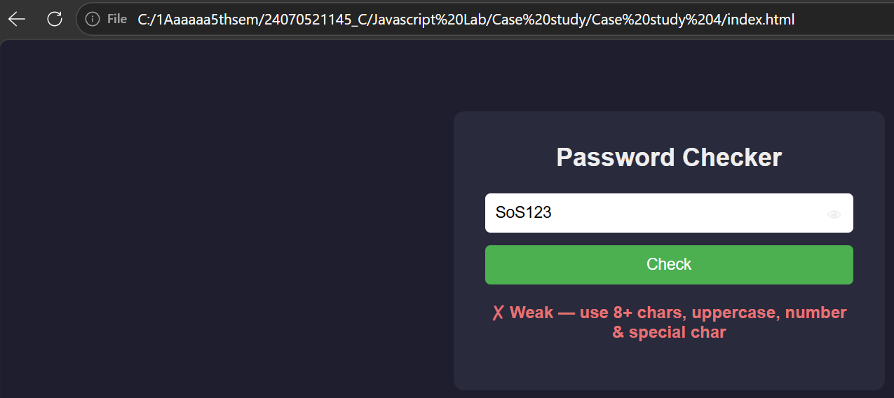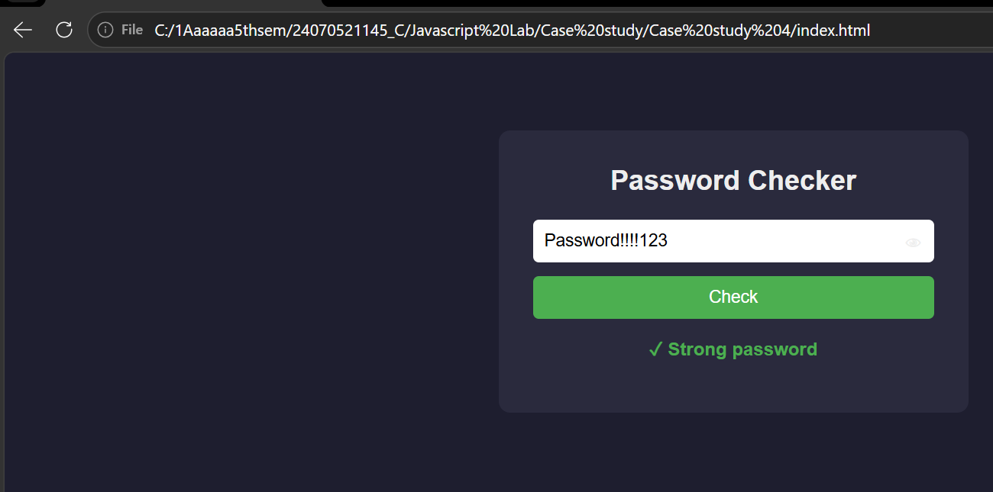

RESULT: Successfully developed and executed a Password Checker web application using HTML, CSS, and JavaScript. The program validates password strength, detects palindrome passwords, provides appropriate user feedback, and includes a show/hide password feature with error handling.

